April James

[jamesap@oregonstate.edu](mailto:jamesap@oregonstate.edu)

CS457 Shaders: Final Project

For my final project, I have been stuck between a few ideas, which I will present here. I will narrow the choice down in office hours, but I would like to list them out here first.

Idea One: Moldy Mushroom

This idea involves creating a random, natural mold pattern on a mushroom (or any object). The mold halo pattern would be created through some noise function, and would create color patterns (similar to oil slicks, but moldy mushroom colors) that change on a sliding scale to simulate mold over time. Or, as a variant, the edges of the mold haloes could have a glowing effect like a neon sign.

Idea Two: Neon Sign

For this idea, I would take an object like a 3D word or recognizable shape and simulate neon tube lighting. I think the approach I would take is to either create a particle system around the object and shine light on the particles where the object is, or create multiple layers of the object and play with their opacities to create a glowing effect. A light flicker could be implemented using a timer in the shader.

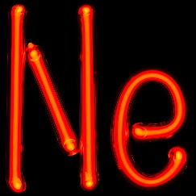

Neon Tube Reference Image

Idea Three: Painterly Shader

I really like traditional art, and after seeing other students’ attempts at painterly shaders, I think it would be a fun project to try as well. For this, I would likely create a couple painterly effects, such as impressionism (nice and smeary), pointillism (lots of dots) and black/white toon effect (from the notes, but I still want to try). Aaron Hertzmann’s paper on Painterly Rendering is very inspiring. <https://mrl.cs.nyu.edu/publications/painterly98/hertzmann-siggraph98.pdf>

Idea Four: Chia Pet

This idea seems the most weird and interesting, but hardest to implement. I like the concept of making a virtual chia pet (like a pet rock but alive, but low maintenance because it’s virtual!). I don’t know how to draw out my idea, but I’m thinking to create a shader where the surface of the object is manipulated into a grassy field, or something similar to a sea anemone or dog toy. Here is an image for reference.

